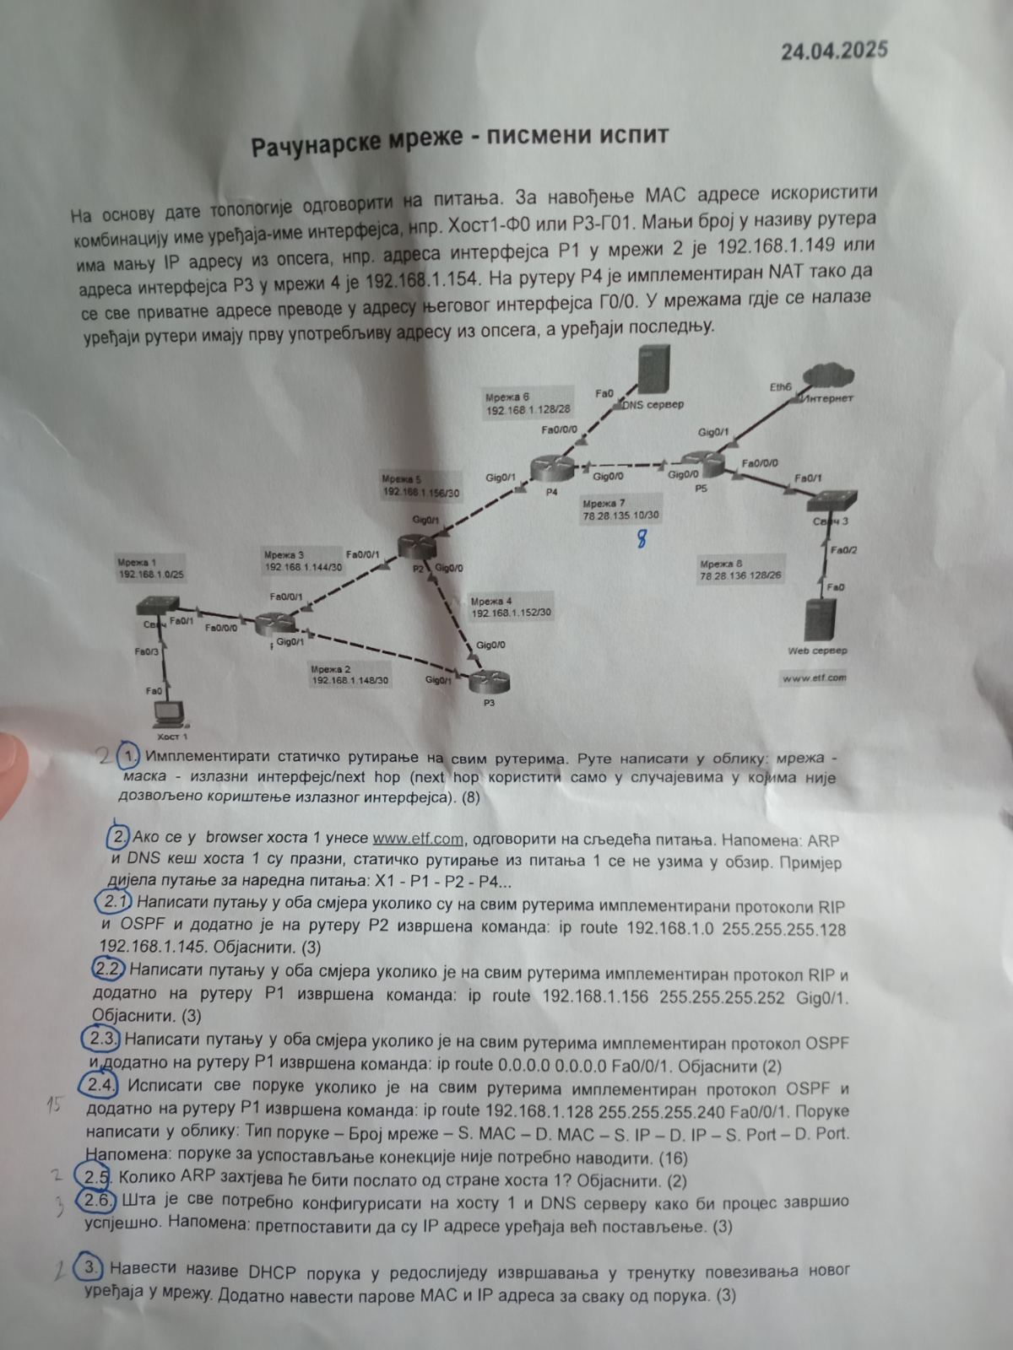

1.Zadatak

R1: 0.0.0.0 – 0.0.0.0 -via Gig0/1( jer Gig interfejsi su mnogo brži no Fa interfejsi..)  
  
R2: 0.0.0.0 – 0.0.0.0 -via Gig0/1  
 192.168.1.0 – 255.255.255.128 via Gig0/0  
 192.168.1.148 -255.255.255.252 via Gig0/0   
  
R3: 0.0.0.0 – 0.0.0.0 -via Gig0/0  
 192.168.1.0 – 255.255.255.128 via Gig0/1  
  
R4: 0.0.0.0 – 0.0.0.0 -via Gig0/0  
 192.168.1.0 – 255.255.255.128 via Gig0/0  
 192.168.1.148 -255.255.255.252 via Gig0/1  
 192.168.1.144 – 255.255.255.252 via Gig0/1  
 192.168.1.152 – 255.255.255.252 via Gig0/1  
   
R5: 0.0.0.0 – 0.0.0.0 -via Gig0/1

2. Zadatak

2.1)  
Oba protkola!!  
***Gledamo u tabelu rutiranja, gledamo administrativne distance:  
C-0, Static-1, OSPF-110, RIP-120, a DefaultRoute je poslednje što se gleda..***(Host1 – R1 – Host1 - R1) – R3 – R2 -R4 – DNS server – R4 – R2 – R1 – Host1 – R1 – R3 -R2 -R4 -R5 - WebServer – R5 – R4 - R2 - R1 - Host1

*Caka je bila u tome da se prilikom DNS Response i HTTP Response saobraćaj odvija sa R4 na R2 pa na R1..Razlog tome je naravno posebna implementacija statičke rute na ruteru R2.*

2.2)  
(Host1 – R1 – Host1 – R1) – R2 – R4 – DNS Server – R4 – R2 - R1 – Host1 – R1 – R2 – R4 – R5 -WebServer – R5 – R4 – R2 – R1 – Host1

*Caka je bila u tome da se statička ruta rutera R1 zanemaruje jer ista nema uticaj na putanju između izvora i destinacije...slušamo RIP..****Trik u 2.1 i 2.2 je bio da razmišljaš kao ruter, pri svakom novom slanju paketa,  
dužan si da pogledaš u svoju tabelu rutiranja!!***

2.3) Statička ruta je Deafult Route što se poslednje gleda u tabeli rutiranja..  
(Host1 – R1 – Host1 - R1) – R3 - R2 – R4 – DNS Server – R4 – R2 – R3 – R1 – Host1 – R1 – R3 – R2 – R4 – R5 – WebServer – R5 – R4 – R2 – R3 – R1 – Host1

2.5) Samo jedan ARP zahtjev. Prije nego što uopšte može da izađe van svoje mreže, Host1 šalje ARP Request kako bi naučio par (IP,MAC) svog Default Gateway-a.

2.6) Oba uređaja moraju imati ispravno podešeno IP, Subnet Mask i Default Gateway ***stim još da DNS server mora imati i „A Record“ tj.tabelu mapiranja tekstualnaAdresa – NjenaIPAdresa!***

2.4)  
  
ARP-Request Mreža1 Host1Mac unknown Host1IP R1IP  
ARP-Reply Mreža1 R1Mac Host1Mac R1IP Host1IP

Idemo: Host1 – R1 – R2 – R4 - DNS  
DNS-Query Mreža1 Host1Mac R1Mac Host1IP DNS_IP 1024+ 53  
DNS-Query Mreža3 R1Mac R2Mac Host1IP DNS_IP 1024+ 53  
DNS-Query Mreža5 R2Mac R4Mac Host1IP DNS_IP 1024+ 53  
DNS-Query Mreža6 R4Mac DNS_ServerMac Host1IP DNS_IP 1024+ 53  
  
Idemo: DNS – R4 – R2 - R3 – R1 – Host1 –NAT!!  
DNS-Response Mreža6 DNSMac R4Mac DNS_IP Host1IP 53 1024+  
DNS-Response Mreža5 R4Mac R2Mac DNS_IP Host1IP 53 1024+  
DNS-Response Mreža4 R2Mac R3Mac DNS_IP Host1IP 53 1024+  
DNS-Response Mreža2 R3Mac R1Mac DNS_IP Host1IP 53 1024+  
DNS-Response Mreža1 R1Mac Host1Mac DNS_IP Host1IP 53 1024+  
  
Slušamo OSPF!! ~~R4(NAT!)interfejsGig0/0IP~~ zamjeni sa WebServerIP !!  
HTTP-Request Mreža1 Host1Mac R1Mac Host1IP ~~R4(NAT!)interfejsGig0/0IP~~ 1024+ 80  
HTTP-Request Mreža2 R1Mac R3Mac Host1IP ~~R4(NAT!)interfejsGig0/0IP~~ 1024+ 80  
HTTP-Request Mreža4 R3Mac R2Mac Host1IP ~~R4(NAT!)interfejsGig0/0IP~~ 1024+ 80  
HTTP-Request Mreža5 R2Mac R4Mac Host1IP ~~R4(NAT!)interfejsGig0/0IP~~ 1024+ 80  
HTTP-Request Mreža7 R4Mac R5Mac R4(NAT!)interfejsGig0/0IP WebServerIP 1024+ 80  
HTTP-Request Mreža8 R5Mac WebServerMac R4(NAT!)interfejsGig0/0IP WebServerIP 1024+ 80  
  
Slušamo OSPF!!  
  
HTTP-Response Mreža8 WebServerMac R5Mac WebServerIP R4(NAT!)interfejsGig0/0IP 80 1024+  
  
HTTP-Response Mreža7 R5Mac R4Mac WebServerIP R4(NAT!)interfejsGig0/0IP Host1IP 80 1024+  
HTTP-Response Mreža6 R4Mac R2Mac R4(NAT!)interfejsGig0/0IP Host1IP 80 1024+  
HTTP-Response Mreža4 R4Mac R3Mac R4(NAT!)interfejsGig0/0IP Host1IP 80 1024+  
HTTP-Response Mreža2 R3Mac R1Mac R4(NAT!)interfejsGig0/0IP Host1IP 80 1024+  
HTTP-Response Mreža1 R1Mac Host1Mac R4(NAT!)interfejsGig0/0IP Host1IP 80 1024+

3. Zadatak.   
DORA!!

1) DHCP Request  
SourceMac SourceIP DestinationMac DestinationIP SourcePort DestPort  
HostMac 0.0.0.0 ff.ff.ff.ff 255.255.255.255 68 67  
  
2) DHSCP OFFER  
SourceMac SourceIP DestinationMac DestinationIP SourcePort DestPort  
DHCP_MAC DHCP HostMac 255.255.255.255 67 68  
  
3) DHCP Request  
SourceMac SourceIP DestinationMac DestinationIP SourcePort DestPort  
HostMac 0.0.0.0 ff.ff.ff.ff 255.255.255.255 68 67  
  
4) DHCP ACK  
2) DHSCP OFFER  
SourceMac SourceIP DestinationMac DestinationIP SourcePort DestPort  
DHCP_MAC DHCP HostMac 255.255.255.255 67 68